Proceedings of the 3rd International Language & Tourism Conference 2019

Sustaining Global Development Goals through
Language, Education and Tourism
Kulliyyah of Languages and Management, International Islamic University Malaysia, Pagoh Edu Hub, Malaysia 18th-19th October 2019

Template for FULL PAPER for
3rd International LANGUAGE & TOURISM CONFERENCE 2019
(ILTC 2019)

First A. Author*¹, Second B. Author2 and Third C. Author3

^{1, 2} Authors’ Department, Institute, City, COUNTRY.
(E-mail: firstauthorsname@aaaa.bbb, secondauthorsname@aaaa.bbb)
³ Author’s Department, Institute, City, COUNTRY.
(E-mail: thirdauthorsname@aaaa.bbb)

ABSTRACT

The abstract should be written in MS Word format in single-spaced in 12-point Calibri. Do not indent the text paragraphs. Please briefly explain the aim and scope of the study, the materials and methods, and the main findings and brief analysis of the study. An abstract not exceeding 300 words should appear on the top of the first page, after the title of the paper in a section titled "ABSTRACT" (without section number), after the names of the authors.
Keywords: (Calibri 12 font, single spacing, not more the five keywords)

1. INTRODUCTION
In this paper, the formatting requirements for the 3rd International Language & Tourism Conference 2019 (ILTC 2019) are described. Some recommendations on writing for a worldwide readership are offered. Please review this document to learn about the formatting of text, table captions, references, and the method to include the indexing information. The conference proceedings will be published in an electronic format. The full paper in MS Word file shall be written in compliance with these instructions.
This format is to be used for submissions that are published in the proceeding of the ILTC 2019. We wish to give this proceeding a consistent, high-quality appearance. We therefore ask that authors follow some simple guidelines. In essence, you should format your paper exactly like this document. The easiest way to do this is simply to download a template from the conference web site, and replace the content with your own material.
Authors are requested to submit the Full paper (maximum of 15 pages in the length) in electronic form (MS-Word) via our email iltc@iium.edu.my. Incorrect formats may result in your abstract being returned to you.
After the conference, selected submissions will be invited to be extended and/or revised into articles for publishing in indexed journals or periodicals.

2. LITERATURE REVIEW

The uniform appearance will assist the reader to read paper of the proceedings. It is therefore suggested to authors to use the example of this file to construct their papers. This particular example uses an American letter format with 25 mm margins left, right, top and bottom.
All text paragraphs should be single spaced, with first line intended by 10 mm. Double spacing should only be used before and after headings and subheadings as shown in this example. Position and style of headings and subheadings should follow this example. No spaces should be placed between paragraphs.

2.1 Fonts
Papers should use 12-point Calibri font. The styles available are bold, italic and underlined. It is recommended that text in figures should not smaller than 10-point font size.

2.3 Tables and Figures
Figure captions and table headings should be sufficient to explain the figure or table without needing to refer to the text.

3. METHODOLOGY

After the text edit has been completed, the paper is ready for the template. Duplicate the template file by using the Save As command, and use the naming convention prescribed by your conference for the name of your paper. In this newly created file, highlight all of the contents and import your prepared text file. You are now ready to style your paper; use the scroll down window on the left of the MS Word Formatting toolbar.

4. MAIN RESULTS

Figures can be included in your extended abstract and referred to in the text.
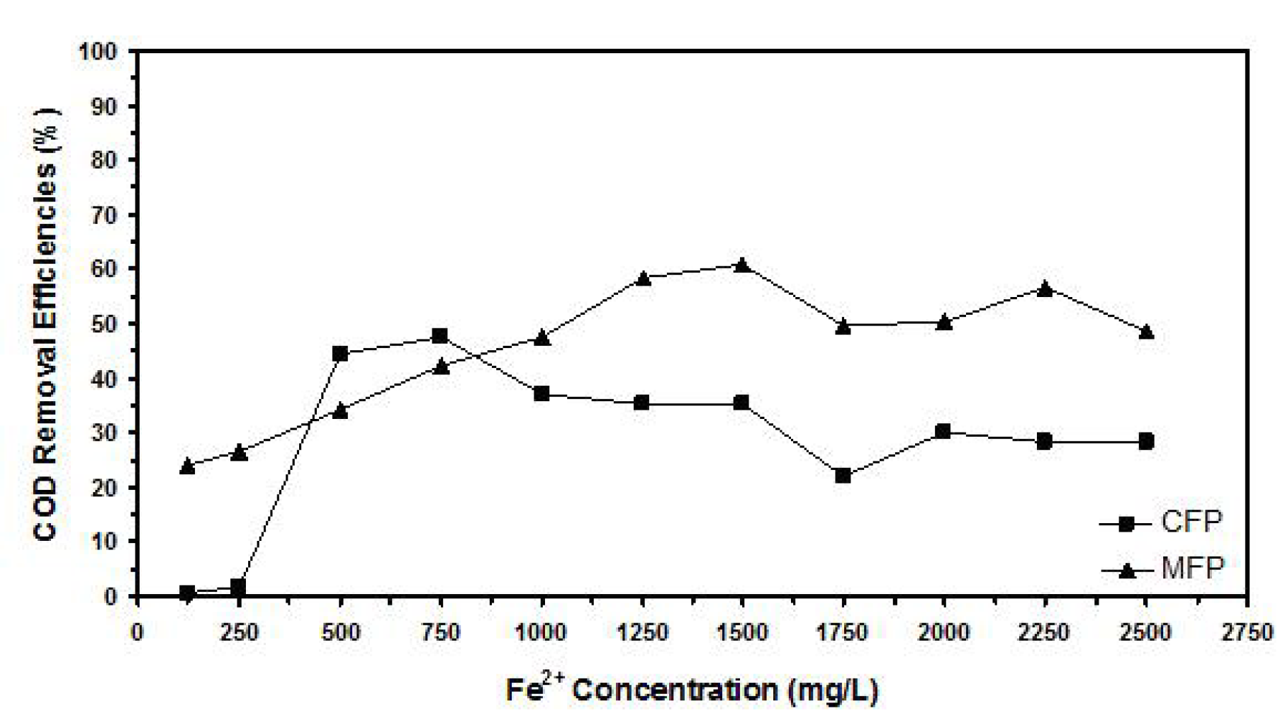

Figure 1. Example of figure for the extended abstract.

A table should be inserted like the one below and referred in the text.

Table 1. Example of table for the extended abstract
Contents of Table

5. CONCLUSION

Conclusions should state concisely the most important propositions of the paper as well as the author’s views of the practical implications of the results.

Bibliography: The biography should mention the presenter’s name, title, affiliation, country, email address and title of the abstract.

Acknowledgment: The authors would like to express their appreciation for the support of the sponsors with Project No xxxx.

REFERENCES
Please use 6th APA Format.

