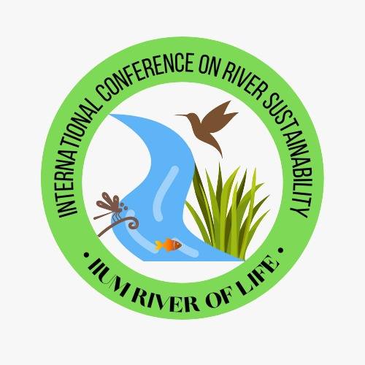
Ahmed Jalal K. Chowdhury¹, Muhbat A. Khan² and Rashida Bt Z. Fakhri^{*1}  ¹Kulliyyah (Faculty) of Science  International Islamic University Malaysia  Jalan Sultan Ahmad Shah, Bandar Indera Mahkota  25200 Kuantan, Pahang Darul Makmur  Malaysia  ²Irrigation Department, N0, 6 JLN Tun Ismail, Kuantan 25200, Pahang  *¹Corresponding Authors: Associate Professor Dr Rashida Binti Zaman Fakhri  PHONE: +609-570 5039  EMAIL: someone@example.com  (Font Size 10 Book Antiqua) | EXTENDED ABSTRACT (Maximum 950-1100 Words)  The extended abstract should be written in English. The writing must be in MS Word format in single-spacing using 10 point of Book Antiqua. Text paragraphs must be justified with no indentation. The length of the abstract is restricted to the maximum of 1-1.5 pages. The extended abstract has to be concise and informative, and comprised of the objective of the study, methodology and the conclusions of the work. The extended abstract can contain a maximum 2 supporting figures or tables. All figures or tables should be centered, and caption should be placed under the figure or tables (see Figure 1 and Table 1).  Figure 1  Source: IIUM ROL, 2020  Item Description  Table 1  Source: KKD, 2019  References should be listed in alphabetical order in a separate page in APA format. Should contain 3 to 5 references.  E.g:  1. Ruxton, C. (2016). Tea: Hydration and other health benefits. Primary Health Care, 26(8), 34-42. https://doi.org/10.7748/phc.2016.e1162  2. Schmidt, N. A., & Brown, J. M. (2017). Evidence-based practice for nurses: Appraisal and application of research (4th ed.). Jones & Bartlett Learning, LLC.  3. Lachner, A., Backfisch, I., Hoogerheide, V., van Gog, T., & Renkl, A. (2020). Timing matters! Explaining between study phases enhances students’ learning. Journal of Educational Psychology, 112(4), 841–853. https://doi.org/10.1037/edu0000396  Keywords: Please provide 3 to 5 keywords only.

