INTERNATIONAL CONFERENCE ON LANGUAGE, EDUCATION AND TOURISM 2026

TAJUK: Template untuk abstrak (Font 14 points, Calibri, Bold, Align Text Centre, Paragraph Spacing 1)

Pengarang*¹, Pengarang² and Pengarang³ (Calibri, 12 points,Bold, Align Text Centre)

¹ Nama, Organisasi, Negara ² Nama, Organisasi, Negara ³ Nama, Organisasi, Negara

*Emel: namapengarangpertama@aaaa.bbb

Keywords: Satu; Dua; Tiga; Empat; Lima (maksimum 5 kata kunci yang disusun mengikut abjad)

ABSTRAK

Bahagian penulisan kertas kerja mestilah berada dalam perenggan pertama. Perenggan hendaklah menggunakan format Calibri, saiz 12, Justified dan setiap perenggan mesti mempunyai 1 selang baris. Jidar untuk semua halaman mestilah normal. Tidak dibenarkan untuk mengubah format dan susun atur gaya yang telah disediakan dalam templat ini. Jangan berikan nombor halaman, kerana nombor halaman akan diubah suai secara berasingan apabila dicetak nanti. Pastikan jarak setiap perenggan adalah 1 selang baris.

Bagi perenggan kedua, harus diasingkan mengikut sub-heading, sub-heading kedua atau sub-heading seterusnya. Format heading ini haruslah HURUF BESAR, Calibri, saiz 12, Bold, jidar penulisan bermula di kiri, serta 1 selang baris pada setiap perenggan. Bagi heading yang kedua, harus menggunakan huruf besar pada setiap pangkal perkataan, format Calibri, saiz 12, Justified, dan setiap perenggan mesti 1 selang baris di antara setiap heading utama. Tinggalkan 2 baris dengan jarak perenggan 1 selang baris (di antara setiap tajuk kecil dan heading utama). Tinggalkan 1 baris dengan jarak perenggan 1 selang baris (di antara setiap tajuk kecil dengan sub-heading yang kedua dan seterusnya)

KAJIAN LITERATUR

Penulisan kajian lepas harus dimulakan dengan perenggan pertama.

Heading Kedua

Perenggan pertama selepas heading kedua. Sub-heading di bawah Heading Kedua Perenggan pertama selepas sub-heading kedua.
H1: Cara penulisan hipotesis kajian (Calibri, 12 points, Italic).

INTERNATIONAL CONFERENCE ON LANGUAGE, EDUCATION AND TOURISM 2026

RESEARCH METHOD

Bahagian utama penulisan kaedah kajian. Penulisan ini mesti bermula dengan perenggan pertama dan diikuti dengan perenggan kedua dan seterusnya.

Heading Kedua

Perenggan pertama selepas heading kedua. Sub-heading di bawah Heading Kedua Perenggan pertama selepas sub-heading kedua.
Semua jadual hendaklah dinomborkan dengan angka (cth. Jadual 1; Jadual 2; ….). Tajuk rajah hendaklah diletakkan di atas rajah dengan saiz 11, Calibri, margin tengah, garis dan jarak setiap perenggan mesti 1 selang baris. Tinggalkan 2 baris dengan jarak perenggan 1 selang baris (di antara perenggan dan rajah). Kandungan jadual hendaklah saiz 11, Calibri, margin tengah dan jarak setiap perenggan mesti 1 selang baris. Tinggalkan 2 baris dengan jarak perenggan 1 selang baris (di antara perenggan dan rajah).

Jadual 1
Contoh data di dalam jadual
Construct | Indicator | Loading | Composite reliability | Cronbach’ s Alpha | AVE¹
Attitude | ATT1 | values | values | values | values
 | ATT2 | values
 | ATT3 | values
Intention | INT1 | values | values | values | values
 | INT2 | values
 | INT3 | values
 | INT4 | values
Nota. Use note here whenever necessary (Calibri, 10 points)

HASIL DAPATAN
Perenggan pertama selepas heading utama

Semua angka hendaklah dinomborkan dengan angka (cth. Rajah 1; Rajah 2; ….). Tajuk rajah hendaklah diletakkan di atas rajah dengan saiz 11, Calibri, Margin Tengah, garis dan jarak setiap perenggan mesti 1 selang baris. Tinggalkan 2 baris dengan jarak perenggan 1 selang baris (di antara perenggan dan rajah). Angka tersebut mestilah berkualiti tinggi dengan resolusi sekurang-kurangnya 300 DPI. Elakkan memberikan ilustrasi yang tidak jelas. Angka itu tidak boleh disendengkan, di luar margin dan mesti dilihat dengan jelas dalam ilustrasi.

INTERNATIONAL CONFERENCE ON LANGUAGE, EDUCATION AND TOURISM 2026

Gambarajah 1
Contoh Rajah (Calibri, saiz 11)

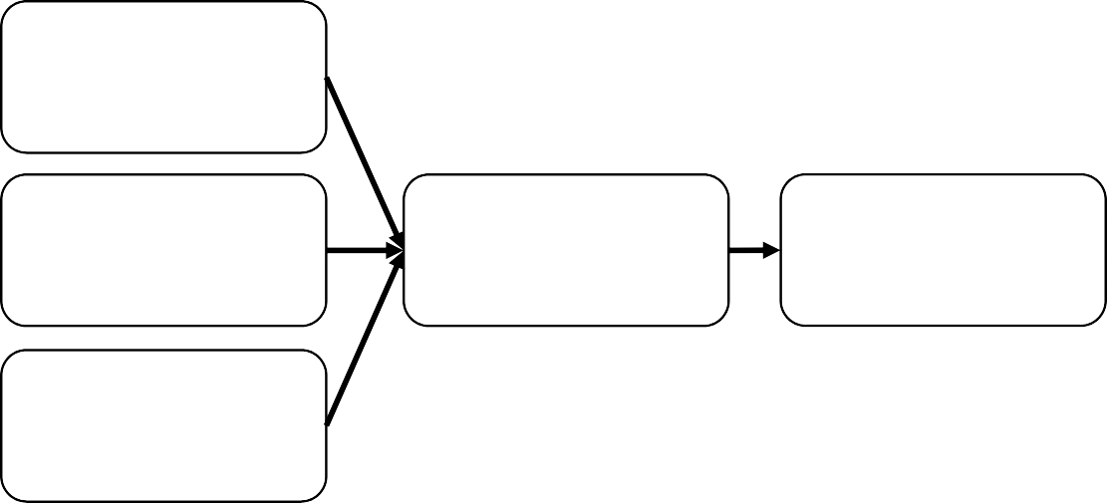
IND. VARIABLE 1
IND. VARIABLE 2
MEDIATING
VARIABLE 4
DEP. VARIABLE
IND. VARIABLE 3

INTERNATIONAL CONFERENCE ON LANGUAGE, EDUCATION AND TOURISM 2026

PERBINCANGAN

Perenggan pertama selepas heading utama.

Heading Kedua

Perenggan pertama selepas heading kedua.

IMPLIKASI

Perenggan pertama selepas heading utama.

LIMITASI DAN CADANGAN KAJIAN

Perenggan pertama selepas heading utama.

RUJUKAN

*Pengarang harus mengunakan format APA (American Psychological Association). Pastikan menyusun rujukan mengikut susunan abjad. Gunakan -1 cm, saiz 11.

Jurnal:
Pérez, A., & Rodriguez del Bosque, I. (2015). Corporate social responsibility and customer loyalty: exploring the role of identification, satisfaction and type of company. Journal of Services Marketing, 29(1), 15-25.

Buku:
Calfee, R. C., & Valencia, R. R. (1991). APA guide to preparing manuscripts for journal publication. American Psychological Association.

Sumber laman sesawang:
Bernstein, M. (2002). 10 tips on writing the living web. A List Apart: For People Who Make Websites, 149. Retrieved from http://www.alistapart.com/articles/writeliving

A SAMPLE OF AN EXTENDED ABSTRACT

Divers’ Willingness to Pay for Conservation Efforts in Malaysia

Ali Abdul

University, Malaysia

*Correspondence: aliabdlim@uni.edu.my

Keywords: Conservation; Diver motivation; Diver satisfaction; Responsible underwater behavior; Willingness to pay

EXTENDED ABSTRACT (The extended abstract can be written in English, Malay or Arabic Language with a total of 1,000 to 1,500 words)

Malaysia's copious marine resources and favorable climate make it a sought-after location for divers. The Professional Association of Diving Instructors (PADI), which is the most extensive diving certification organization globally, disclosed that approximately 900,000 divers get certified each year, resulting in a total of 25 million certified divers worldwide.

While diving tourism generates employment opportunities and economic activities such as training, underwater guides, dive masters, and boat operators, it is crucial to manage diving sites effectively and implement conservation measures to mitigate the negative impacts that such activities may cause (Booth et al., 2022). The potential environmental drawbacks and adverse effects outweigh the economic and social benefits. For instance, human activities have placed marine species such as sharks, rays, turtles, and cetaceans in perilous situations (Booth et al., 2022). This research aims to investigate whether the satisfaction, motivation, and responsible behavior of divers have an impact on their willingness to pay for a conservation fee or permit in Malaysian diving destinations.

LITERATURE REVIEW

Willingness to Pay

Activities that utilize marine biodiversity resources in the maritime sector are frequently undervalued as their cost is challenging to rationalize. This could lead to insufficient funding, resulting in environmental degradation. User fees can assist in marine conservation efforts. If managed correctly, user fees can provide financial support for environmental conservation. It is essential for users of the maritime environment to contribute to its

sustainability by paying user fees, which can then be allocated towards conservation endeavors. These user fees typically apply to activities such as entry, exit, and diving.

Motivation of Divers and Willingness to Pay

Most tourism industries use travel motivation to determine tourist engagement and travel patterns. It is a driving factor that encourages tourists to travel to destinations that satisfy their desires. Divers are willing to pay extra for great marine life, decent water conditions, interesting underwater settings and sceneries, and a wide diversity of fishes (Grafeld et al., 2016; Schuhmann et al., 2019; Trujillo et al., 2016).

Responsible Underwater Behavior and Willingness to Pay

Incompetence, insufficient scuba diving skills and knowledge, and a lack of specialization among divers have the potential to cause permanent coral damage (Pepe, 2010). Previous studies have established a correlation between divers' specialization and training level and their responsible behavior underwater, indicating that well-educated divers are more likely to be conscientious (Allkins et al., 2021; Thapa et al., 2006). Divers who possess a good education and have undergone training appreciate the environment and are more likely to support conservation initiatives by paying for them.

Diver Satisfaction and Willingness to Pay

Research has demonstrated a connection between diver satisfaction and the financing of conservation efforts. A captivating location with excellent amenities that meets the expectations of tourists and divers can optimize profits, benefit the local community, and safeguard the environment (Duran-Roman et al., 2021). Contented tourists are willing to pay more to enhance their travel experiences and mitigate negative impacts (Yu et al., 2018).

Research Hypotheses

H1 Motivation of divers to engage in a dive expedition affects the divers’ willingness to pay for
conservation efforts.
H2 Divers’ responsible underwater behavior affects divers’ willingness to pay for conservation
efforts.
H3 Diver’s satisfaction affects divers’ willingness to pay for conservation efforts.

RESEARCH METHOD

The aim of this study is to gather quantitative data from a group of divers who have visited diving sites in Malaysia. The study's minimum sample size of 74 respondents is based on the recommendations of Tabachnick and Fidell (2007). To collect data, a non-probability survey questionnaire was utilized. Given the constraints of the COVID-19 pandemic, the Google Form was selected as the data collection tool. The survey was distributed through several Malaysian scuba social media groups such as Scubajunkie, Malaysia Diving Community, and @clubnomad on Facebook, WhatsApp, and Instagram, with the intention of reaching potential respondents. IBM SPSS Statistics version 26 was employed to analyze the acquired data.

The measurement scale for domestic divers' motivation was adapted and adopted from Carvache-Franco et al. (2020), while the measurement of divers' responsible underwater behavior was based on Allkins et al. (2021). The satisfaction of divers was assessed using Musa et al. (2008), while the willingness of divers to pay for conservation activities was evaluated using Pedroso and Biu Kung'u (2019) and Schuhmann et al. (2019). Furthermore, three open-ended questions were presented to the respondents to determine their understanding of conservation fees and their stance on paying for marine park conservation fees. The reliability of the scales, along with the mean and standard deviation, are presented in Table 1.

Table 1

Descriptive Statistics
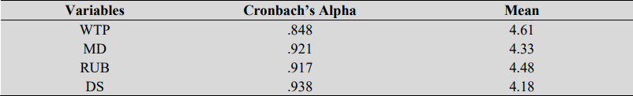

Note. WTP - Willingness to Pay, MD - Motivation of Divers, RUB - Responsible Underwater Behavior, DS - Diver Satisfaction.

Sample Profile

Out of the total number of participants, which was 110, the majority were males, making up 54.5% of the sample. The largest age group was those aged between 41 and 50, accounting for 34.30% of the respondents. The majority of the participants were employed, with students and pensioners comprising 16.4% and 8.2% of the sample, respectively. More than half (54%) of the respondents had a monthly income of over RM 6,000, while only 24.5% earned less than RM 1,500 per month. The majority of the participants (47.3%) held an Advanced Open Water Diver certification and typically dived with 4-to-6 fellow divers (50.9%). As for vacation duration, 61.8% of the respondents chose to stay for 4-to-6 days.

RESULTS

Multiple Regression Results

The model's R-square value was able to account for 53.5% of the variation in the willingness to pay for conservation efforts. The independent variables' tolerance values were all greater than .10, and the VIF values were less than 10, indicating that there was no issue of multicollinearity.

Table 2

Coefficient Analysis
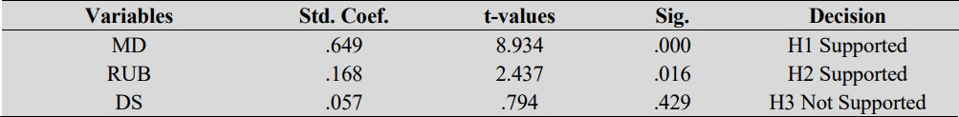

Note. WTP - Willingness to Pay, MD - Motivation of Divers, RUB - Responsible Underwater Behavior, DS - Diver Satisfaction. a. Dependent Variable: Willingness to Pay.

Hypotheses Testing

The findings indicate a significant correlation between divers' motivation and their inclination to pay for conservation activities, with a beta coefficient of .649 and a p-value of
.000, thereby supporting H1. Furthermore, the outcomes revealed a positive link between responsible underwater behavior and the willingness to pay for conservation initiatives, with a beta value of .168 and a p-value of .016, confirming H2. Conversely, there was no apparent connection between diver satisfaction and willingness to pay, as evidenced by a beta value of .057 and a p-value of .429, leading to the rejection of H3.

DISCUSSIONS

The findings of this study are consistent with previous research (Roberts et al., 2017), which suggests that divers place a high value on the conservation of marine life, reefs, and biodiversity. Divers who have a strong appreciation for the natural environment and its preservation, including coral and water quality, are more inclined to contribute to conservation efforts (Schuhmann et al., 2019). Moreover, environmentally conscious divers tend to behave more responsibly while diving.

Previous studies have also found a correlation between environmental consciousness and the willingness to contribute to marine conservation efforts (Daly et al., 2015; Yu et al., 2018). Moreover, research suggests that education plays a role in environmental awareness and participation in conservation activities (Arin & Kramer, 2002). It is worth noting that

while the divers in this study reported high levels of satisfaction with their diving experience and the services provided, this did not necessarily translate into a strong desire to support conservation efforts.

FUTURE RESEARCH DIRECTIONS

Further investigation is required to apply the results more broadly. Policy objectives, such as achieving a sustainable and just blue economy, could potentially benefit from the untapped revenue source provided by marine tourism, which could assist in financing marine conservation initiatives (Booth et al., 2022). Future studies should also explore the willingness to pay for conservation among non-divers or individuals engaged in other marine recreational activities. Additionally, future research should pay more attention to international divers visiting Malaysia and consider the impact of political and social factors.

REFERENCES

Allkins, M. E., Tshipala, N. N., & Hermann, U. P. (2021). Scuba divers’ attitudes towards responsible behaviour and profile. African Journal for Physical Activity and Health Sciences (AJPHES), 27(1), 1–15. https://doi.org/10.37597/ajphes.2021.27.1.1
Booth, H., Mourato, S., & Milner-Gulland, E. J. (2022). Investigating acceptance of marine tourism levies, to cover the opportunity costs of conservation for coastal communities. Ecological Economics, 201, 107578.
Grafeld, S., Oleson, K., Barnes, M., Peng, M., Chan, C., & Weijerman, M. (2016). Divers’ willingness to pay for improved coral reef conditions in Guam: An untapped source of funding for management and conservation? Ecological Economics, 128, 202–213.
Pepe, S. L. (2010). Caution diver below! A case for enhanced environmental education and policies to raise awareness of sustainable scuba diving. ProQuest Dissertations and Theses,68.http://ezproxy.msu.edu/login?url=http://search.proquest.com/docview/7 56051234?accountid=12598%0Ahttp://za2uf4ps7f.search.serialssolutions.com/?ctx_ ver=Z39.88-2004&ctx_enc=info:ofi/enc:UTF8&rfr_id=info:sid/ProQuest+Dissertations
+%26+Theses+Global&rft_val_
Schuhmann, P. W., Skeete, R., Waite, R., Lorde, T., Bangwayo-Skeete, P., Oxenford, H. A., Gill, D., Moore, W., & Spencer, F. (2019). Visitors’ willingness to pay marine conservation fees in Barbados. Tourism Management, 71(October 2018), 315–326. https://doi.org/10.1016/j.tourman.2018.10.011
Tabachnick, B. G., & Fidell, L. S. (2007). Using Multivariate Statistics. In PsycCRITIQUES (5th ed., Vol. 28, Issue 8). Pearson Education Inc. https://doi.org/10.1037/022267
Thapa, B., Graefe, A. R., & Meyer, L. A. (2006). Specialization and marine based environmental behaviors among SCUBA divers. Journal of Leisure Research, 38(4), 601–615.
Trujillo, J. C., Carrillo, B., Charris, C. A., & Velilla, R. A. (2016). Coral reefs under threat in a Caribbean marine protected area: Assessing divers’ willingness to pay toward conservation. Marine Policy, 68, 146–154.

