EXTENDED ABSTRACT TITLE
(TIMES NEW ROMAN, 12 FONT SIZE, BOLD, ALL CAPS, CENTERED)

Author’s Name and Surname^{1*}, Author’s Name and Surname² (11-pt, Times New Roman)
¹Organization information that the author is affiliated with
²Organization information that the author is affiliated with
*Corresponding author’s email: [email@example.com]

- INTRODUCTION (Times New Roman, 12 pt, Bold, All Caps)
The extended abstract should follow a structured format and be more concise than the full paper. It must include the following sections: Introduction, Literature Review, Method, Results and Discussion, and Conclusion. The text should be in Times New Roman, 11 pt, single line spacing, and fully justified.
Extended abstracts may include figures, tables, formulas, or images. The content should effectively summarize the study, including its preparation phase. Page margins should be 2.5 cm on all sides (A4 size). Text should be fully justified without hyphenation. The extended abstract should be minimum of 4 pages and maximum of 5 pages, including references.
British English should be used throughout. Abbreviations should be spelled out in full the first time they appear. Numbers ten and below should be written in words. Foreign language phrases should be italicized (e.g., Latin, French).

- LITERATURE REVIEW / BACKGROUND (Times New Roman, 12 pt, Bold, All Caps)
Relevant literature should be reviewed to identify research gaps and situate the current study in relation to prior research.
Literature review may include figures, tables, formulas, or images with references. The text should be in Times New Roman, 11 pt, single line spacing, and fully justified.

  - Subtitle (Times New Roman, 11 pt, Bold, Title Case)

First-level headings (e.g., 2. LITERATURE REVIEW) should be left-aligned, in all caps, and bold. Second- (e.g., 2.1. Subtitle) and third level (2.1.1. Sub-subtitle) subheadings should be left-aligned, bold, and in title case. A blank line should be inserted between paragraphs, with no paragraph indentation.

- METHOD / APPROACH (Times New Roman, 12 pt, Bold, All Caps)
All materials and methods used in the study must be clearly stated. Subheadings should be used where necessary. The text should be in Times New Roman, 11 pt, single line spacing, and fully justified

- RESULTS AND DISCUSSION / FINDINGS / OUTCOME (Times New Roman, 12 pt, Bold, All Caps)
All materials and methods used in the study must be clearly stated. Subheadings should be used where necessary. The text should be in Times New Roman, 11 pt, single line spacing, and fully justified.

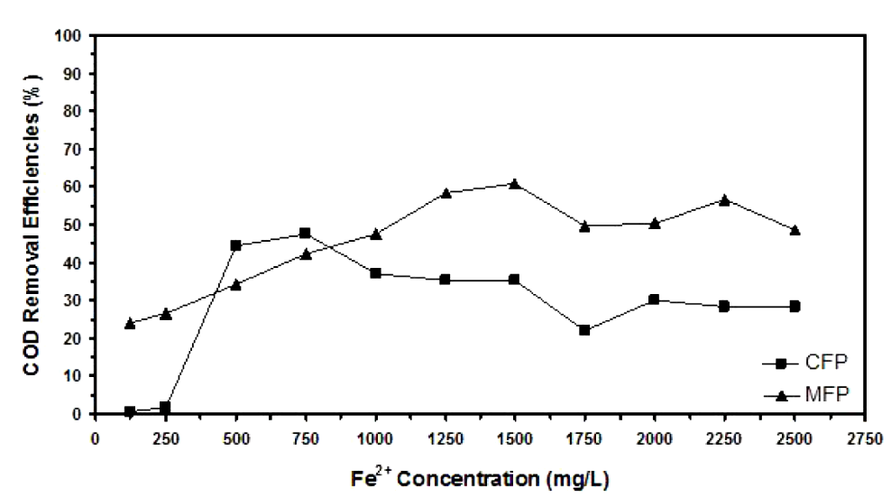
Figure 1. Example of figure for the extended abstract.

A table should be inserted like the one below and referred in the text. Please avoid vertical rules and shading in table cells.

Table 2. Table Header
Factor | Unit | Low | High
Final temperatures | °C | 200 | 600
Heating rate | °C/min | 1 | 10
Holding time | Min | 0 | 60
N2 flow rate | L/min | 0.2 | 1.0
Condensing temperature | °C | 0 | 10

Reference: author surname and publication date (eg: George, 2009)
4.1. Subtitle (Times New Roman, 11 pt, Bold, Title Case)
All tables, figures, and images should be centered. Figures and images should be numbered sequentially (e.g., Figure 2) with captions placed below them. Tables should also be numbered sequentially (e.g., Table 2) with headers placed above them. Table and figure captions should be bold, centered, and use uppercase initials.
- CONCLUSION (Times New Roman, 12 pt, Bold, All Caps)

The conclusion should summarize the most important findings of the study and suggest directions for future research. The text should be in Times New Roman, 11 pt, single line spacing, and fully justified.

Keywords: Maximum of five words, written in Times New Roman, 10 pt, separated by semicolons.

ACKNOWLEDGEMENT (Times New Roman, 12 pt, Bold, All Caps)

Acknowledge any research grants, organizations, or scholarships that supported the study, if applicable.

REFERENCES (APA Style) Only references cited in the extended abstract should be listed. The reference list should follow the latest APA format.

Berawi, M.A., (2004). Quality Revolution: Leading the Innovation and Competitive Advantages. International Journal of Quality & Reliability Management, Volume 21(4), pp. 425–438 (Journal articles)
Harris, M. (2014). The GRO Green Roof Code. Final report of Green Roof Code of Best Practice for the UK 2014. Available online at: https://livingroofs.org/wp-content/uploads/2016/03/grocode2014.pdf, Accessed on 14 February 2017

Notes to Author:
Total words count for extended abstract paper must not more than 1,500 words (not including table, figure and references). All extended abstracts submitted to the conference will go through a full review process, according to the journal's regular process. All registered and accepted extended abstract submissions will be published as proceeding papers in the ICABE 2026 Conference Proceedings.

